**WAM WEB ACCCESS MODULE CHECK LIST**

**Introduction**

The present document covers steps needed to personalize WAM Web Access Module pages. Some aspect of the pages can be personalized to your Central station including using your logo. One hour of graphic personalization is included in your purchase of WAM. This includes changing text for you and uploading your company logo.

WAM installation is done by MCDI on server your select. This bare server should be running either Windows (IIS) or Linux (Ubuntu or CentOS) where MCDI can be allowed to install its own copies of Lighhtpd, PHP, PostgreSQL, deploy database table and OpenVPN. Remote access to server is required (Remote desktop or SSH). Ftp access is required.

STM ST Mobile web viewer is also included with your purchase of WAM license. Ftp access to server is required to upload STM data. Refer to STM documentation for set-up.

Some details of the operation of WAM are specified in this document.

**CHECK LIST FOR WAM SET-UP**____Twitter account

____Facebook account

____Contact content of all locations

____Phone number for direct dial mobile version

____Language selection

____Help page content with documents to link

____Contact page content, latest news

____Electronic copy of logo

____Screen shot of text (language verification)

____Language file translation (other language)

____Domain name dedicated to WAM server

**Link to twitter account**No_____ Yes______

If no, icon will be removed.

If yes, indicate the twitter handle @________________________  
  
**Link to Facebook page**No_____ Yes______

If no, icon will be removed.

If yes, indicate the Facebook page ___________________________________________________

**Phone numbers**  
For mobile pages, the red phone icon  triggers dialing in most phones.   
Phone number of your Central station as it would be dialed on a mobile phone___________________________

**Language**

Please select default language: ________________________  
This language will be the default for all your subscribers. Current translation is in English, French, Spanish, Romanian and Russian. If you need another language contact MCDI support to get the translation file. MCDI can integrate your translation.

**Selecting a server**

In selecting a server, you should be guided by anticipated use by your customer i.e. number of customer using WAM simultaneously. As a rule of thumb MCDI suggest to prepare for a peak of 10% of active subscribers i.e. if you have 5000 active accounts, web server should be able to handle up to 500 subscribers accessing WAM without suffering from lag.   
  
If using a server inside your Central station, be aware of bandwidth needed. Upload stream should be sufficient for anticipated needs.   
  
Contact MCDI to discuss benchmark and servers.

**Domain name**

A domain name is required if using WAM server. WAM service may be using a subdomain of securithor.org such as yourcentralname.securithor.org or securithor.org/yourcentralname.

The domain name serves two purposes. It is the public address of your server and is needed to configure a mail server our your WAM server. It can be any domain name you own but it need to be dedicated to this task. Access to DNS zone (a, cname, mx record) is necessary to set address of server.

**Contact page**Contact page layout is 4 containers with the following information:

A.Main contact info including form to send message  
Email address to send result of the web contact form____________________________________

Send Description and phone numbers you want to add

This file can be modified later by you using a text file contact.txt using the regular html tags such as:

Links should be complete url between tags:

<ahref="insert link here"> </a>

Bold characters should be between tags:

<strong>Insert text here</strong>

The contact.html file should be uploaded to ftp in folder WAM>DWAM>content or using the uploader located in group administration> Settings page. Go to last choice at bottom of the page upload file. Select file and click on upload. Changes should be visible within 10 seconds.

N.B.: uploading through the settings page is the only choice available is using WAM service.

B.Our locations:  
Please state all location you want to add.

This file can be modified later by you using a text file locations.txt using the regular html tags such as:

Links should be complete url between tags:

<ahref="insert link here"> </a>

Bold characters should be between tags:

<strong>Insert text here</strong>

The location.html file should be uploaded to ftp in folder WAM>DWAM>content or using the uploader located in group administration> Settings page. Go to last choice at bottom of the page upload file. Select file and click on upload. Changes should be visible within 10 seconds.

N.B.: uploading through the settings page is the only choice available is using WAM service.

C.Latest news/About us  
Please state all information you want to write. This file can be modified later by you using a text file news.html using the regular html tags such as:

Links should be complete url between tags:

<ahref="insert link here"> </a>

Bold characters should be between tags:

<strong>Insert text here</strong>

The news.html file should be uploaded to ftp in folder WAM>DWAM>content or using the uploader located in group administration> Settings page. Go to last choice at bottom of the page upload file. Select file and click on upload. Changes should be visible within 10 seconds.

N.B.: uploading through the settings page is the only choice available is using WAM service.

D. twitter feed and link  
This container contains a script to load to your Twitter account. It will automatically link to and display the latest tweets you posted.   
Twitter account: @_____________________

Alternatively you can change the twitter link yourself by writing the complete twitter url in the twitter.txt file. The twitter.txt file should be uploaded to ftp in folder WAM>DWAM>content or using the uploader located in group administration> Settings page. Go to last choice at bottom of the page upload file. Select file and click on upload. Changes should be visible within 10 seconds.

N.B.: uploading through the settings page is the only choice available is using WAM service.

This will change the twitter feed and the link to twitter web site.

E. Facebook Link.  
All Facebook logo are link to a facebook page. You can change this facebook page at wll by writing url or facebook page in facebook.txt file.

The facebook.txt file should be uploaded to ftp in folder WAM>DWAM>content or using the uploader located in group administration> Settings page. Go to last choice at bottom of the page upload file. Select file and click on upload. Changes should be visible within 10 seconds.

N.B.: uploading through the settings page is the only choice available is using WAM service.

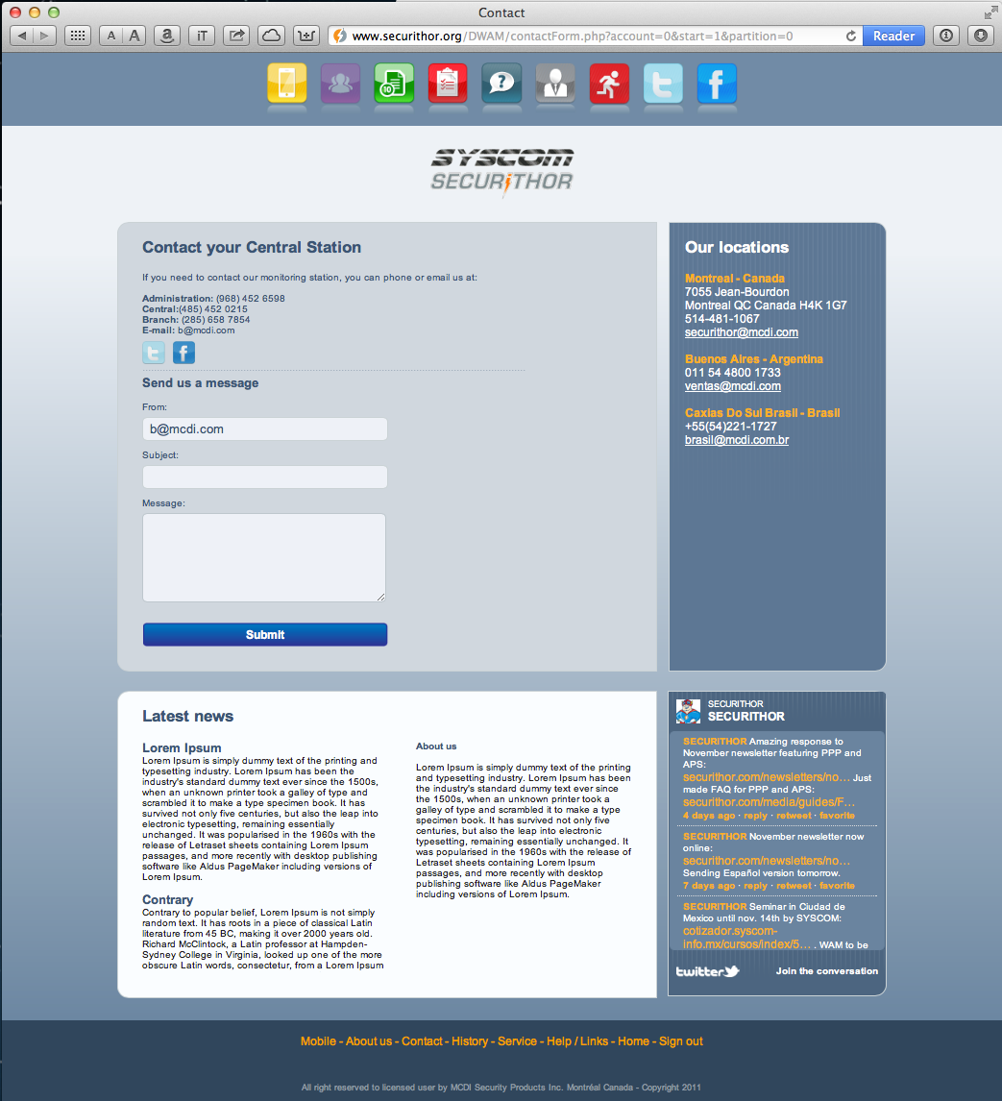

**LOGO**   
A logo of your Central can be used on the front page and some key pages like the help and contact pages.

It is preferable to keep a smaller logo around 68 pixels height x 200 pixels width. This will insure a faster load time, less bandwidth and compatibility with mobile pages.

Send electronic copy of logo to MCDI in gif, jpeg, tiff, ai, psd, svg.   
High resolution will make for better results. MCDI will reduce size to fit best.  
  
Recommended final size on web page: 80 pixels height x 200 pixels width.   
Width could be as much as 960 pixels. Height of more than 100 pixels will unbalance graphic layout but could be made. It will also compromise the display of mobile pages.  
   
Logo can have transparent background. Please indicate which color to remove or supply logo with transparent background (png,gif, svg, ai).

See the following logo examples for positioning. Logo is placed between top icon bar and main content in the desktop pages. The logo width in this example is 180 pixels for a height of 68 pixels. With of the page content is 960 pixels.

Desktop page:

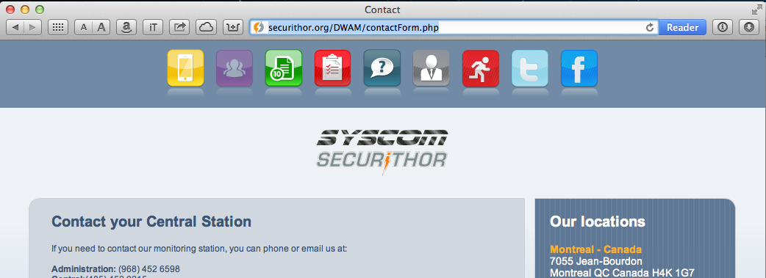

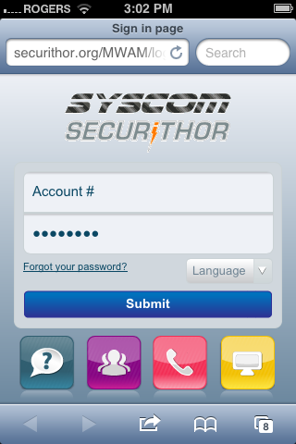

**Mobile page**:

In this example logo width is 180 pixels width and height is 68 pixels. The total size of the mobile page should be less than 320 pixels width X 480 pixels height.

To keep bandwidth low and on insure graphic layout its most mobile phone, it is recommended to keep logo under 280 pixels x 68 pixels.

A smaller logo will load faster.

The logo file should be uploaded to ftp in folder (replace current logo file) or using the uploader located in group administration> Settings page. Go to Upload a small size logo and Upload a splash screen logo depending on file you want to upload. Select file and click on upload. Changes should be visible within 10 seconds.

N.B.: uploading through the settings page is the only choice available is using WAM service.

**HELP PAGE**  
Help page is a template made by MCDI. There are two sections which can be filled with your ARC content. Content will be common to all languages.

First section is Links  
Second section is Documentation.

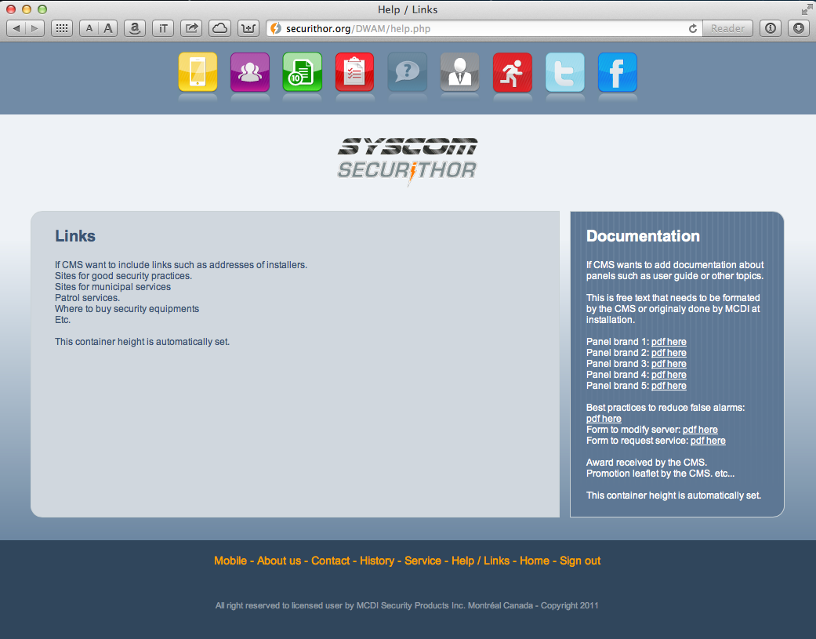

N.B.: it is preferable to have the same amount of content in both sections in order to maintain de graphic look.

The help.html file should be uploaded to ftp in folder WAM>DWAM>content or using the uploader located in group administration> Settings page. Go to last choice at bottom of the page upload file. Select file and click on upload. Changes should be visible within 10 seconds.

N.B.: uploading through the settings page is the only choice available is using WAM service.

**Links**

States any link you want to inscribe including the URL of this link. A short description of the link may be written if you wish.  
  
N.B.:   
.MCDI staff may not be fluent in your language. Help us understand which words constitute the link and how to separate sentences and paragraphs.

. If using a double byte alphabets, please prepare a screenshot of your text so we can verify if accents and special characters are correctly displayed.

.You will have the possibility to review the layout and publishing once entered.

To edit the Links container yourself, you can fill the links.txt file.

Links should be complete url between tags:

<ahref="insert link here"> </a>

Bold characters should be between tags:

<strong>Insert text here</strong>

The links.html file should be uploaded to ftp in folder WAM>DWAM>content or using the uploader located in group administration> Settings page. Go to last choice at bottom of the page upload file. Select file and click on upload. Changes should be visible within 10 seconds.

N.B.: uploading through the settings page is the only choice available is using WAM service.

**Documentation**This is a column to the right of the help page. Write information you would like to see such as manual/user guides of panels you install, other document you wish your customers to view such as best practices to reduce alarms, links to request service, awards received by your Central, brochure of your services etc…

N.B.:   
.MCDI staff may not be fluent in your language. Help us understand which words constitute the link and how to separate sentences and paragraphs.

. If using a double byte alphabets, please prepare a screenshot of your text so we can verify if accents and special characters are correctly displayed.

.You will have the possibility to review the layout and publishing one entered.

To edit the Documentation container yourself, you can fill the documents.txt file.

Links should be complete url between tags:

<ahref="insert link here"> </a>

Bold characters should be between tags:

<strong>Insert text here</strong>

The documentation.html file should be uploaded to ftp in folder WAM>DWAM>content or using the uploader located in group administration> Settings page. Go to last choice at bottom of the page upload file. Select file and click on upload. Changes should be visible within 10 seconds.

N.B.: uploading through the settings page is the only choice available is using WAM service.

**Using the CMS page to change CMS identification and logo**To access the CMS page, log with account 0 password securithor.   
Path to acces the CMS page is only available to admin and account 0.   
  
To access CMS page, some pages have a ‘CMS page’ link at bottom.   
Otherwise click on administrator icon at top and then click on CMS page icon or enter the url: http://yoursubdomainhere.securithor.org/DWAM/cmsForm.php

Changes made in the CMS page should be entered one line at a time. Click on modify button to the right of the change field each time you want to change corresponding data. This will upload to server. You will be redirected back to the CMS page once the change is uploaded to the server.

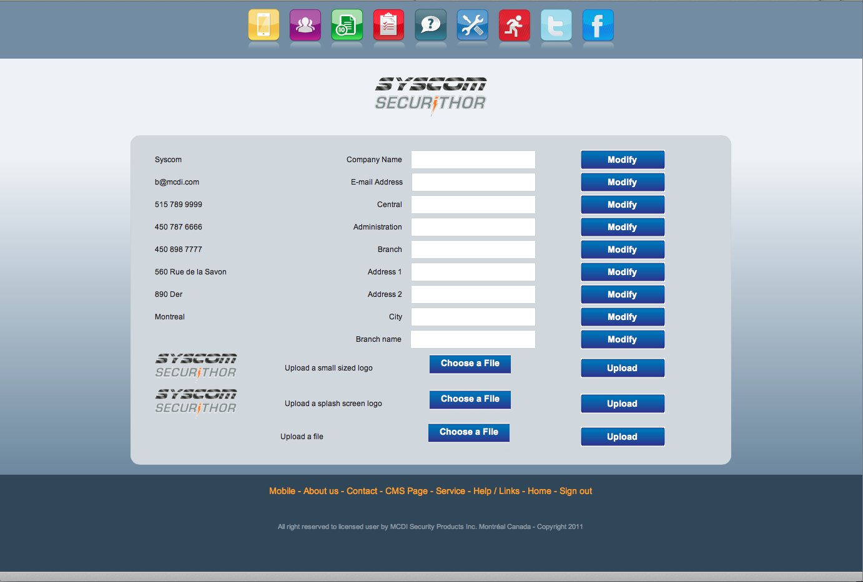

**Using MCDI demo server**

While using MCDI demo server, ftp access is not available. To upload files, go to the CMS configuration menu. To access this menu use account 0 and password securithor.

Click on top icons administrator > CMS page 

or click on the link CMS Page that appears at the bottom of the administrator page

or

enter the url:

http://name_given_by _MCDI.securithor.org/DWAM/cmsForm.php

Upload feature is located at the bottom of the CMS page. Upload files one by one. This will overwrite previous file on server. Previous file cannot be restored unless you kept a copy and re-upload it.

Verify changes.

**Configuration of Securithor for WAM**License should be enabled for WAM. If not already, contact MCDI to purchase the WAM module licensing or get proper license.

To enable WAM to go STnet.   
If necessary unlock STnet (default password: securithor)

Select Tools>Web Access Module

Enable: Active  
URL: enter IP address of server or dns resolve name  
Password: as selected or provided by MCDI  
Database name: as instructed by MCDI

Save changes. This will enable uploading a partial replication of your Securithor’s database. Original upload includes data from the last 3 months. This is a partial database and cannot be viewed as a backup in any case. Depending on size of database and   
  
**WARNING**: each time you enable/disable or save, a new database upload will start and will overwrite existing database on WAM server.

**VPN**MCDI uses OpenVPN on both endpoints. It will be set-up along with your WAM. If you wish to use another VPN method, please contact MCDI first.

**WAM service**

Hosting of WAM is available for CMS with less than 500 accounts. MCDI maintains a web server and offers shared hosting. Contact MCDI staff [securithor@mcdi.com](mailto:securithor@mcdi.com) to contract this hosting. Web Servers are currently located at iweb.com in Montreal on servers controlled by MCDI.   
  
WAM service requires specific Securithor versions due to particularity of web hosting.

**Administrator page**

**To access the administrator page, log with account 0 password securithor  
The only administrator is account 0   
N.B.: Status cannot be changed for account 0**

Account: all accounts from Securithor are transferred to WAM  
All passwords are initially transferred from Securithor to WAM

Password: they can be modified in WAM independently from Securithor.   
N.B. Making a complete re-upload of Securithor database will reset passwords to the ones registered in Securithor database.

Status: enabled/disabled  
Enabled allows account access to WAM.   
Disabled disallows account access to WAM  
  
Email: can be specified for each account. This will make a preset for contact forms if access within the account.

**Group administrator**Group administrator privileges is not transferred from Securithor. It is totally independent from Securithor.   
  
A group administrator or master user is allowed to view all accounts under his province e.g. the administrator of a group including all restaurants of a chain will view all restaurants accounts under the administrator page and can change their WAM passwords and emails, enable/disabled these accounts.

Account 0 is the master user to all accounts. All traffic is listed under account 0.

Example below shows how to set a master account for a group. A blank line is inserted under each account. This line is used to specify accounts wich master account can view. In case of account 1234 it can also view accounts 1235 and 4545. All partitions of accounts 1234, 1235, 4545 will be viewed within account 1234.

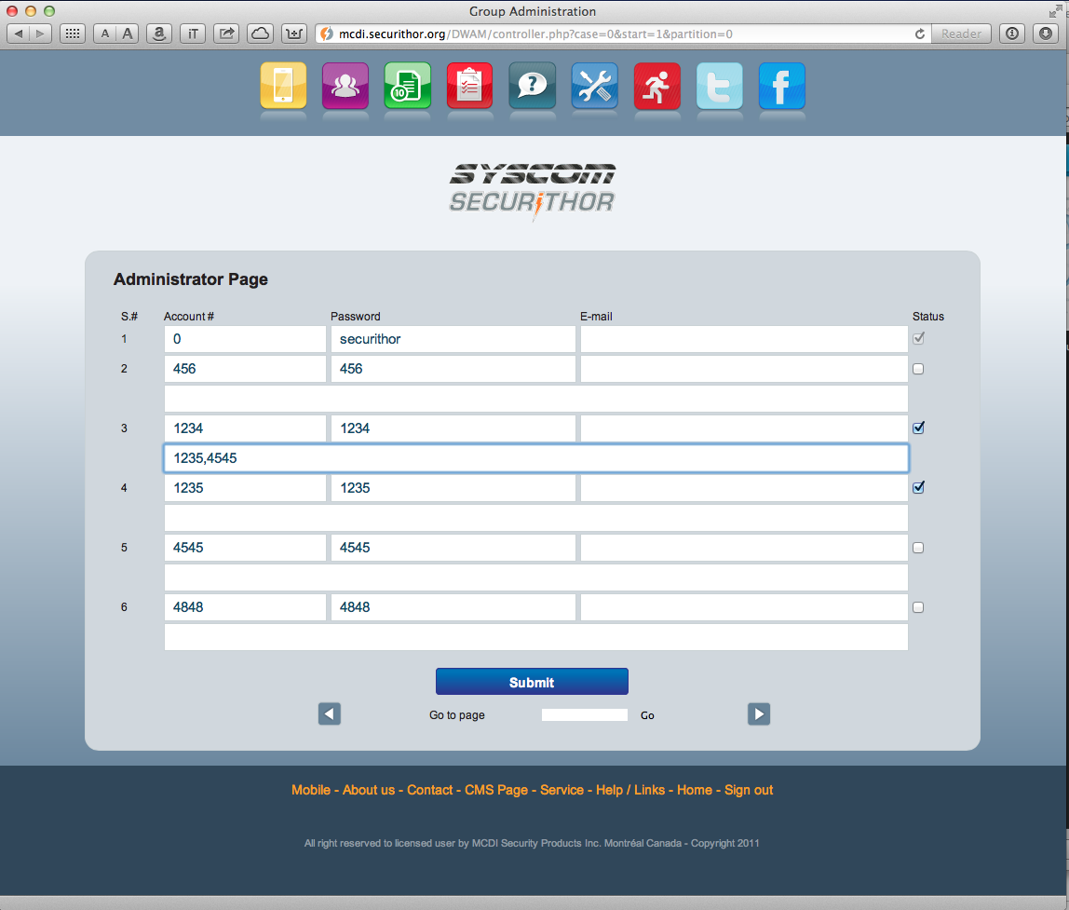

**Group viewing in WAM**

Account information states Master account info. Account number will state sub-accounts. In case show below, master account 1234 groups accounts 1235 and 4545.

When viewing a group from a master account, Viewing schedules will not be available in master account. Schedule container is left blank (grey zone).  
  
In Alarm Traffic, the display is slightly changed.   
List now states: Green Color = Disarmed, Red Color=Armed.

Traffic now groups all traffic from joined account and is displayed by descending arrival time. Armed disarmed status icon is replaced by change of color for partition number. This status is only valid for the latest alarm arrived for individual partition.

Ascending/descending sort can be set to account#, partition#, alarm code, description

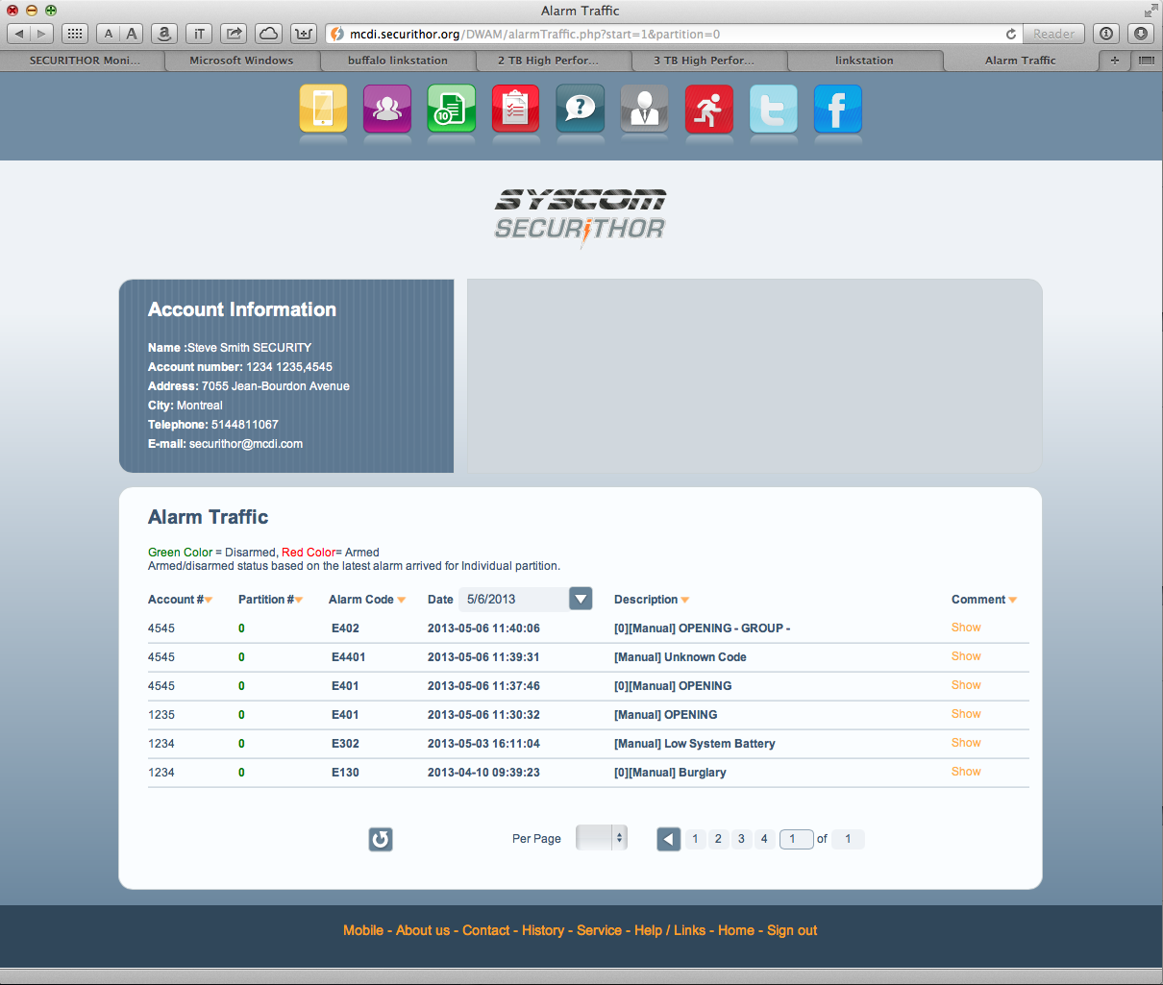

**GENERAL CONSIDERATIONS**.MCDI staff may not be fluent in your language. Please insure you explain which world should be linked.

.If using a non roman alphabet or one the contains special characters not typically included in the French or English languages, please provide a sample screenshot of your text so we can compare.

.Links require a complete URL. Insure the http address is complete and valid.

.Content files may be .txt or word.   
  
.If some words are to be in bold, please state which ones.

.Font used in the pages is arial. Cannot be substituted.

Considerations for using WAM:

-For initial upload, your Securithor database is partially copied to WAM server. Only releveant tables are copied (3 months data).This can take up to several hours depending of number of accounts, number of events, available bandwidth and writing speed of the hdd on server.

-WAM server only uses its own database to serve information to subscribers. No direct query to Securithor is made by subscribers accessing WAM.

-To insure WAM information is up to date, a constant link between Securithor and WAM is required. Securithor uploads new information to WAM as it becomes available. Changes to accounts and new alarm events are uploaded to WAM as they are created in Securithor. Permanent connection with sufficient bandwidth should be kept open. 100KB/s upload speed takes care of most needs while 60KB/s is considered typical for a busy Central station with 5000 accounts or less.

-OpenVPN could be used between Securithor and WAM server.

Icons description   
  
**Desktop pages:**

All pages except Administrator and CMS page



Administrator and CMS page:



**Mobile pages icons:**

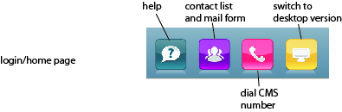

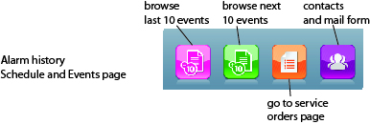

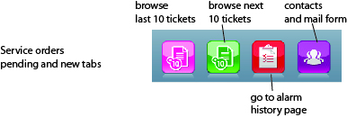

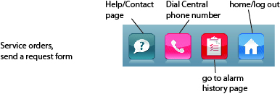

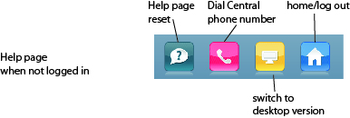

MCDI 2012.11.26.1  
Revised 2013.01.15  
Revised 2013.01.23: Added CMS page explanation, upload feature for share server, icons description  
Revised 2013.06.06 Added group administration explanation. WAM service consideration added.